**GROWTH DATA COLLECTION MANUAL WITH YEARLY OPERATION**

**KOBOTOOLBOX SERVER**

1. CREATE NEW ACCOUNT
2. CLICK THE CONFIRMATION LINK FROM KOBOTOOLBOX SENT TO YOUR MAIL ID
3. LOGIN

**OPERATIONS TO DO EVERY YEAR:**

1. DOWNLOAD THE EXCEL FILE AFTER DATA COLLECTION

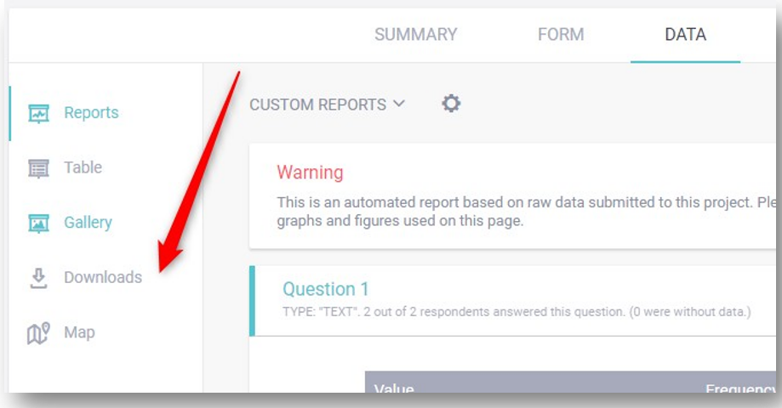

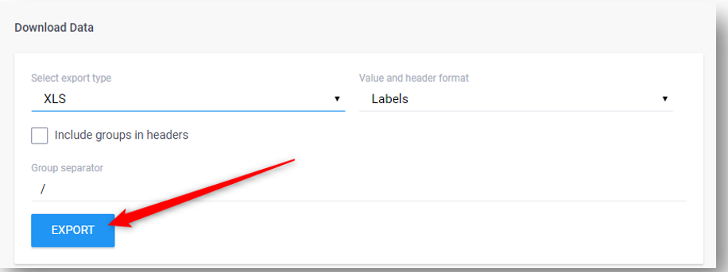

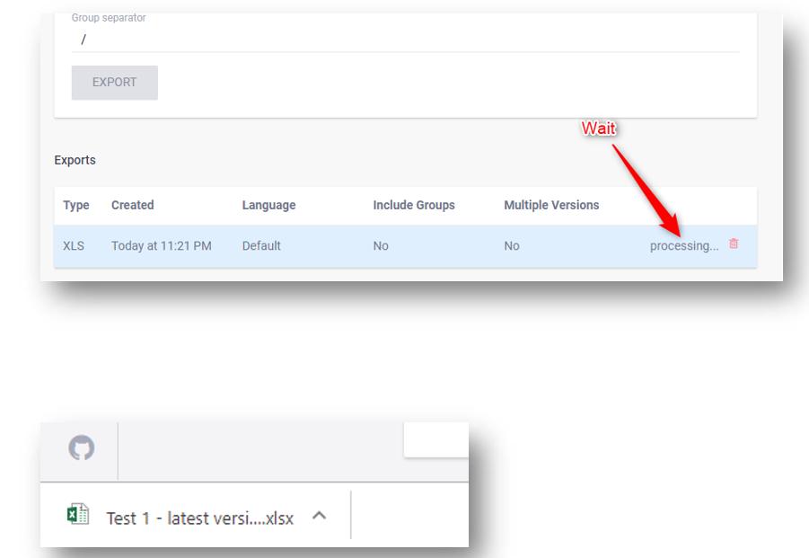

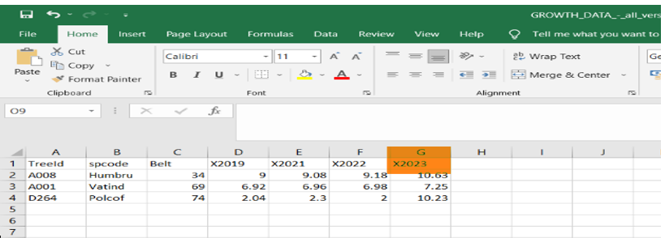



SINCE THE TREEID IS NOT IN CORRECT ORDER SORT IT

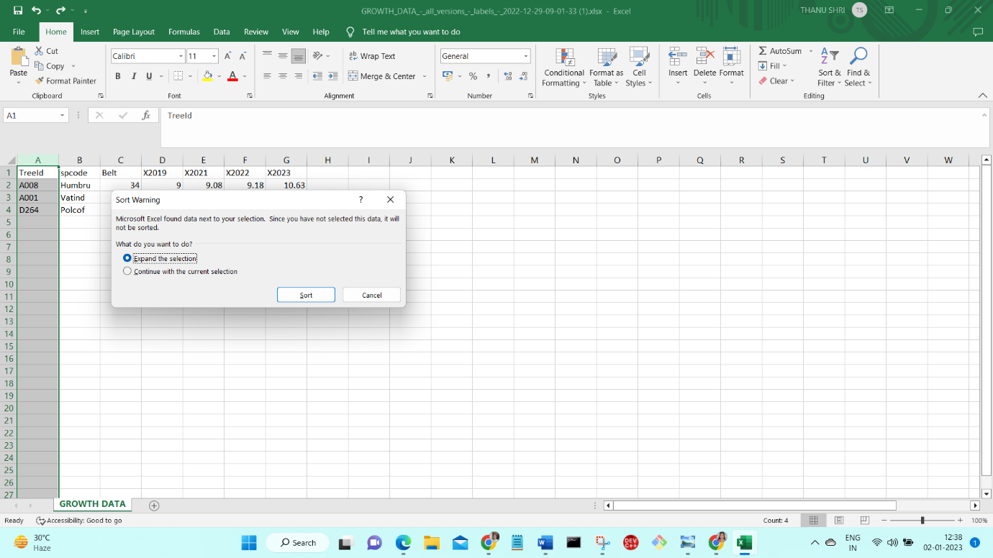

AFTER SORTING THE TREE ID

COPY THE CURRENT YEAR READING AN GIRTH NOTE TO PASTE IT IN THE CSV FILE LATER

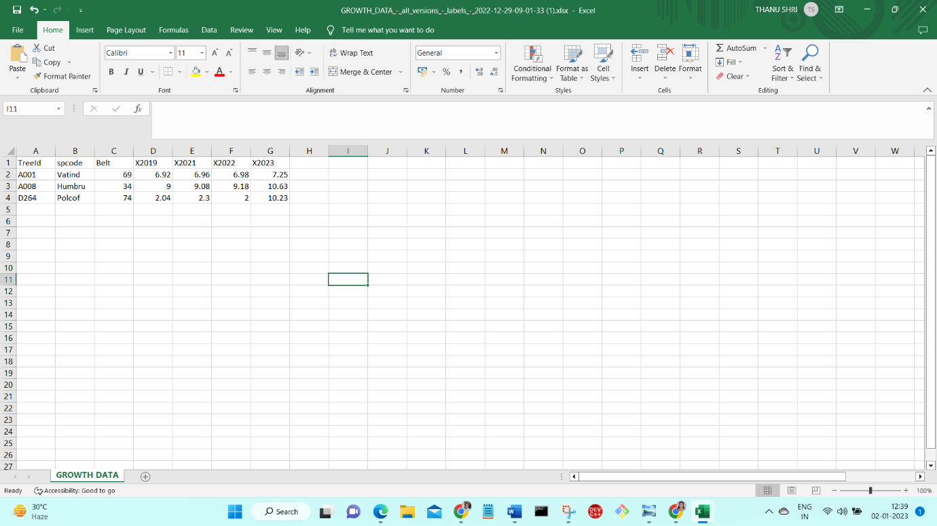



GO TO SERVER -> SETTINGS -> MEDIA -> tree.csv _> after clicking that file will be opened

Then PASTE X023 AND GITH NOTE OF CURRENT YEAR READINGS WHICH WAS PREVIOUSLY COPPIED FROM DOWNLOADED EXCEL FILE IN THE ABOVE PICTURE

YOU CAN ADD IT IN ANY COLUMN

AND SAVE THIS FILE TO REUPLOAD IN SERVER

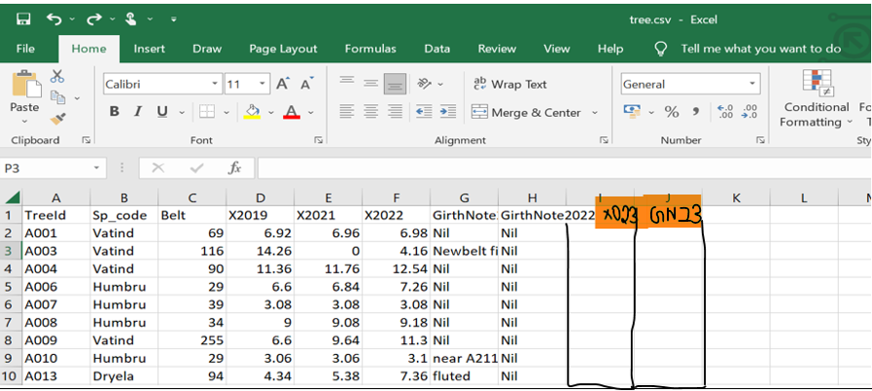





REUPLOAD CSV FILE

DELETE PREVIOUSLY EXISTING OLD tree.csv AND

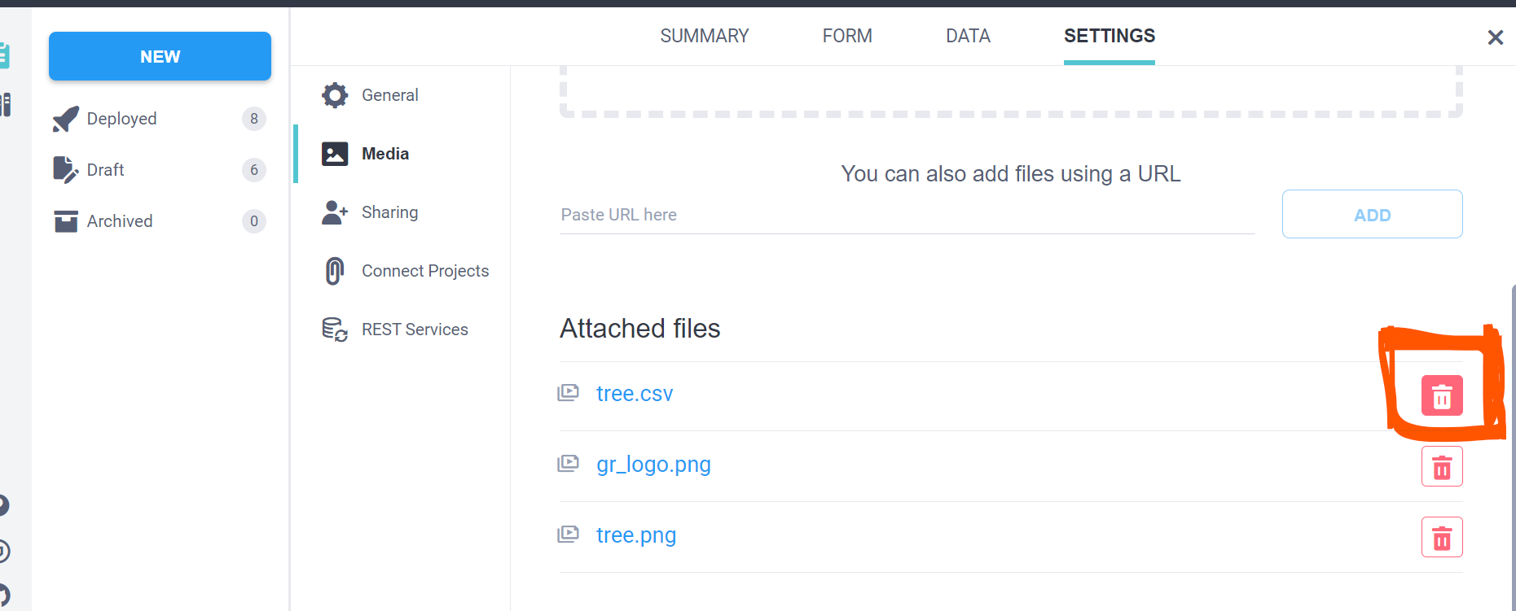

REUPLOAD SAVED FILE AFTER UPDATING THE CURRENT YEAR READINGS TO THE SERVER

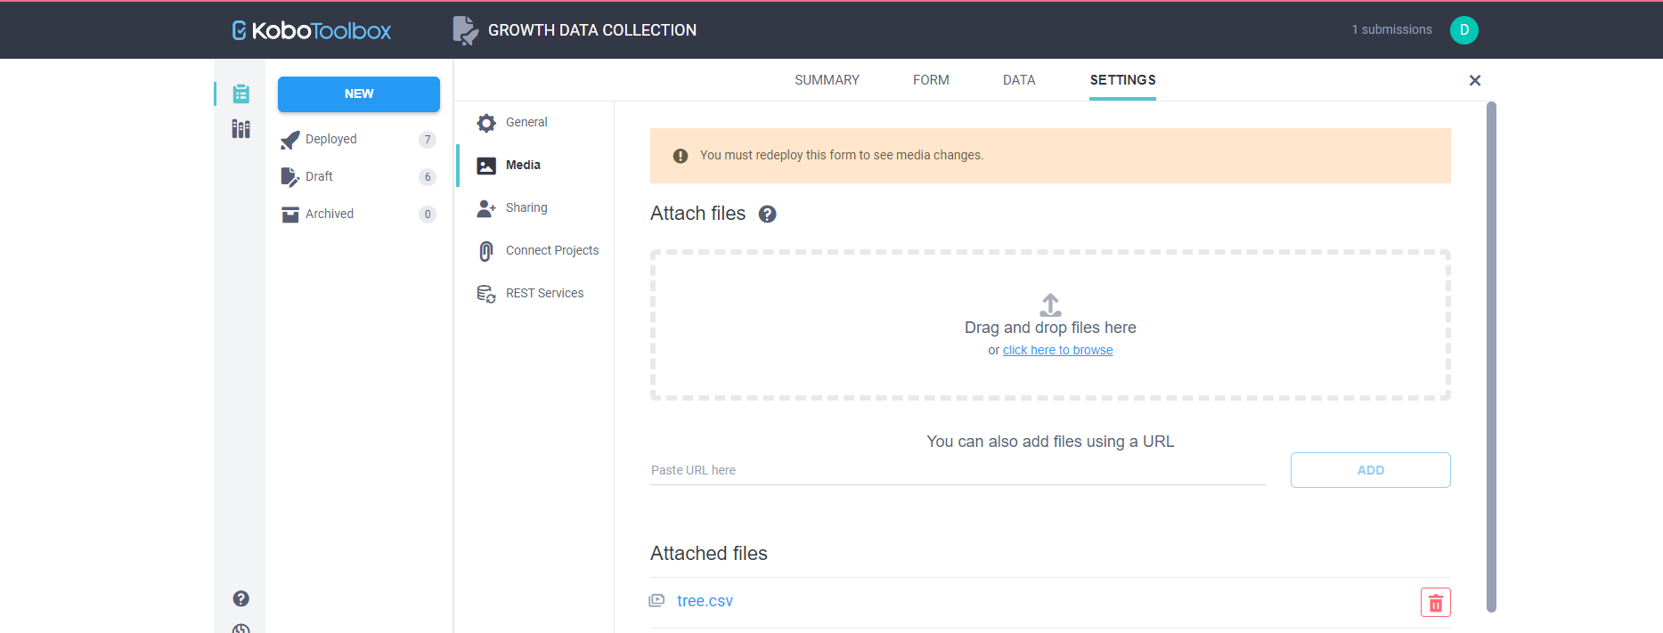

2) EACH YEAR STARTNG MONTH/ DAY **REPLACE** THE **EXCEL FILE** (WHICH CONTAINS YEAR FUNCTION THAT AUTOMATICALLY UPDATES THE CURRENT YEAR) BY CLICKING THE REPLACE FORM ICON TO GENERATE FORM FOR THE CURRENT YEAR.

AS EACH FORM IN KOBOTOOLBOX CAN BE GENERATED FROM AN EXCEL FORM AFTER UPLOADING ITIN SERVER

THIS IS THE ABOVE MENTIONED EXCEL FILE

-CHECK WHETHER FOR EACH YEAR,THE YEAR(EG)-X2023) HAVE BEEN UPDATED.

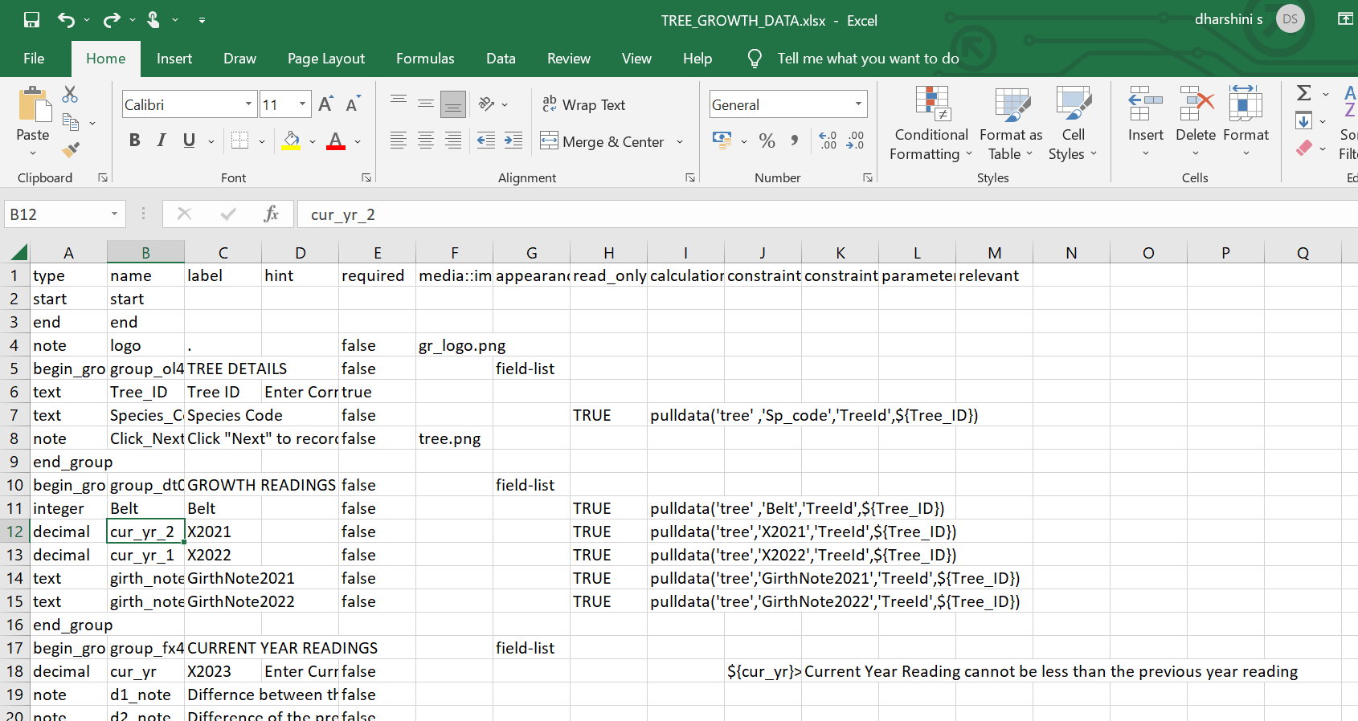

THEN UPLOAD IT BY CLICKING REPLACE FORM ICON

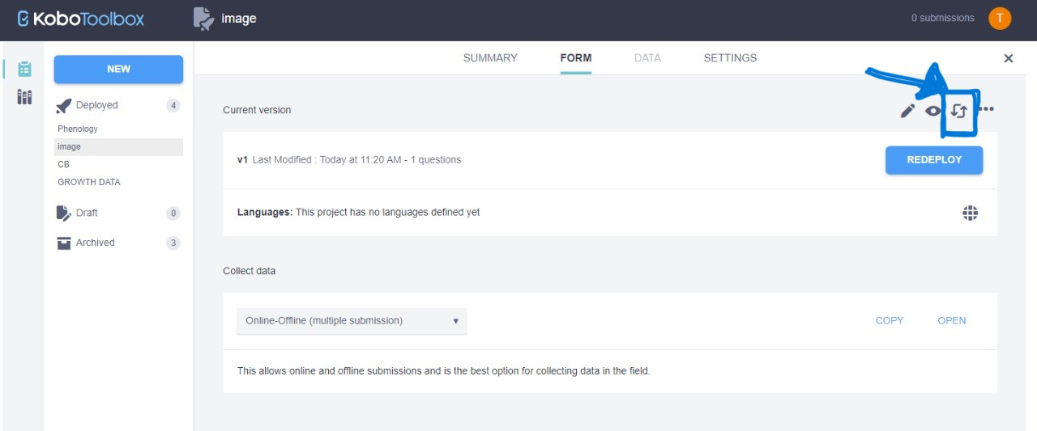

UPLOAD THE ABOVE MENTIONED EXCEL FILE

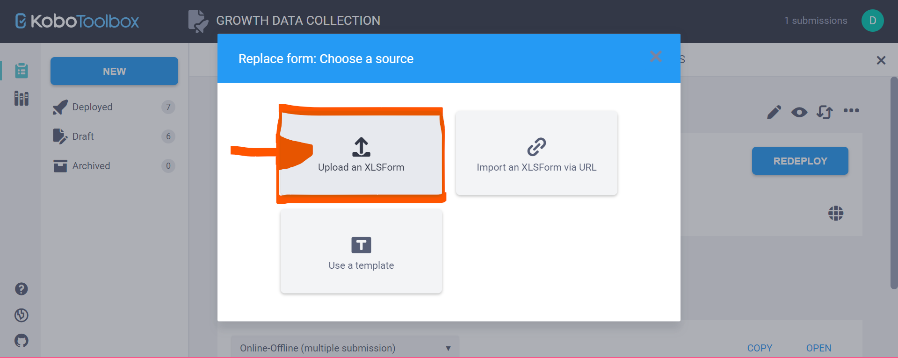

AND THEN Redeploy form TO SEND THE UPDATED FORM TO ANDROID DEVICE

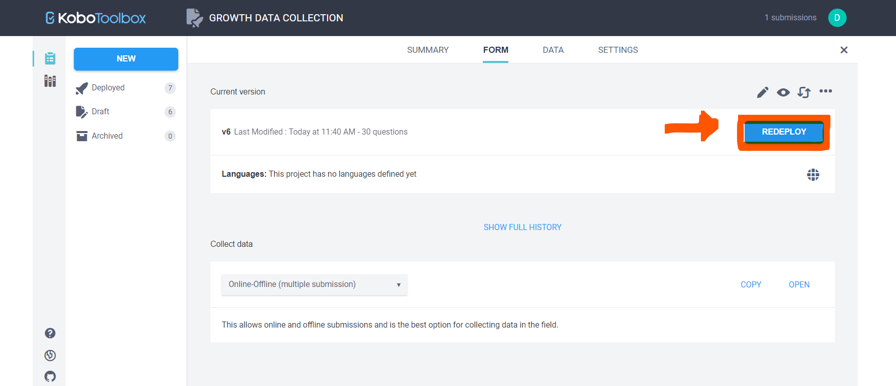

THAT’S ALL THE FORM IS NOW READY TO COLLECT DATA FOR THE NEW YEAR AND SINCE WE UPDATED THE DATA IN CSV FILE IT WILL BE AUTOMATICALLY PULL THE PREVIOUS YEAR READINGS .

**KOBOCOLLECT ON ANDROID**

1) Install kobo collect app from google play store

2) click on “Manually enter project details” option.

3) in add project enter **URL** in this form –“ [https://kc.kobotoolbox.org/**username**](https://kc.kobotoolbox.org/username)

4) Enter your username and password

5) click add

6)Click “ **GET BLANK FORM “** to get the forms from server and click “**get selected”**

**7) “fill blank form”** to collect data in the field

**8)** After reaching end of the form click on **“save form and exit”**

**9) repeat steps 7) and 8) for each entry**

**10) Send all the finalized forms to server by clicking the “send finalized form” button(you can send all the saved forms at the same time)**

EACH YEAR AFTER REDEPLOYING THE FORM CLICK **“GET BLANK FORM “** TO UPDATE THE FORM**.**

AND **“CLICK GET SELECTED”**

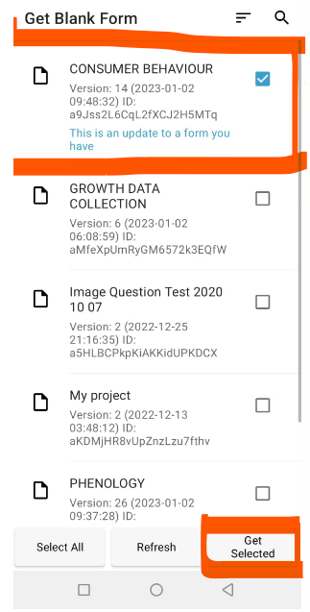

**AND THEN FILL BLANK FORMS ,SAVE IT AND SEND FINALIZED FORMS TO SERVER.**